

**By**

**Sunil Raj Thota**

**Date: 06/16/2021**

**Title: Individual Project Proposal: 3rd Draft**

**ALY 6080 – Integrated Experiential Learning**

**Prof. Atherley, Valerie**

**Introduction:**

Asthma is one of the world's most common chronic diseases, and it is characterized by fast deterioration. Allergy asthma is the most common type of asthma. Patients with asthma have allergies at a rate of 90 percent, compared to 50 percent of those surveyed with asthma. In some people, infections that cause sneezing fits and runny nose can also cause an asthma attack. Keva Health Inc is a technological platform that provides tailored health care to everyone. The Experiential Network (XN) Project was sponsored by this company in collaboration with Northeastern University.

For instance, computational monitoring of huge amounts of information on state of health and medicine use, as well as several other infection data like health information, could also be used to guide individualized interventions that have a favorable potential effect, such as creating habit and effective utilization. The main goal is to help patients who are searching for innovative and inventive approaches to overcome and offer care for something like a spectrum of related diseases. These therapy roadblocks could be driven by the availability of digital technologies.

**Problem:**

Organizations who wish to take advantage of big data must reevaluate their methodological approach from a development perspective. The most critical question to be asked when working with large amounts of data is privacy. There is a waste of memory and bandwidth. It hasn't been typed. Because, for illustration, is read-only, we don't have entire authority. This is particularly true of poll data, but it also applies to a wide range of certain other statistics. Statistics, like anything else, can be viewed in many different of ways. Economic indices, for example, are a continual reminder of this. Various communities attempt to make sense of various monthly statistics, and the same data is frequently made clearer by several organizations.

**Goals:**

I'm writing this based on the references I've gathered and mentioned below. Persons with severe respiratory disorders continue to have poor outcomes despite the establishment of innovative treatments. As we all know, Keva Health Inc is a health-care platform that relies on its own real-time monitoring system, which enables everyone to receive personalized health care. Give decisions based on the patterns we have created. Employ analytics provided by big datasets (Airnow, ER visits in the United States) to make a stunning representation of air quality and the opportunity to examine its effect on ER visits associated to Asthma.

**Analysis:**

The Keva Health software platform allows respondents to access medical records, gain feedback tailored to identified areas of weakness, and evaluate and obtain feedback on the progress personality practices. They have set up a virtual functional requirement to provide clinicians with the data they want to assist asthma sufferers live better lifestyles. Keva Health, a healthcare technology business, is known for establishing digital healthcare activities and setting the stage for online treatment that goes further ehealth.

Through blending powerful data functions associated with fact self-monitoring techniques, it expects to increase deep compliance and interaction with soul techniques. Individuals experience individualized, insights and recommendations in accordance to their problems and peak flow metrics, and they can receive notifications from their doctor's office concerning current therapy.

* Develop a customer interface that enables people to communicate with clinicians
* Decisiveness, constant improvement, measurement, reporting, and advancement are all priorities
* It's straightforward to comprehend the patient ’s condition, which aids in the creation of tailored analyses
* Use Survey questionnaire, Assessments, and Exams to collect medical information, outcomes, and recommendations
* AI-assisted comprehensive health analytics provides personalized treatment suggestions

We also done some analysis in R and Python to dive deep into the datasets and see the patterns in them. We also decided to do some machine learning algorithms like Linea Regression, Decision Tree Modeling, Random Forest, and XG Boosting methods to get the accuracy and other metrics from it.

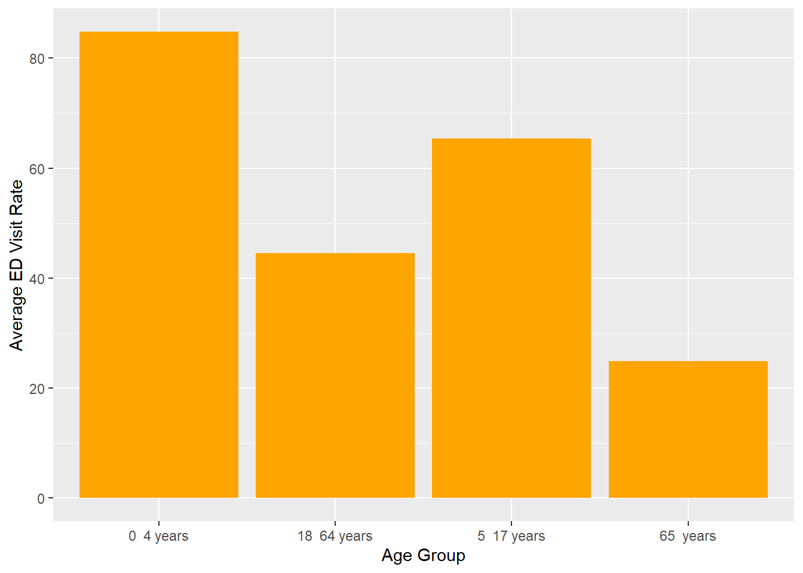

This graph shows the ED Visit rate summarized values which are adjusted to their means. 0 - 4 years age group has average ED Visit rate as the most and got to see more than 80.

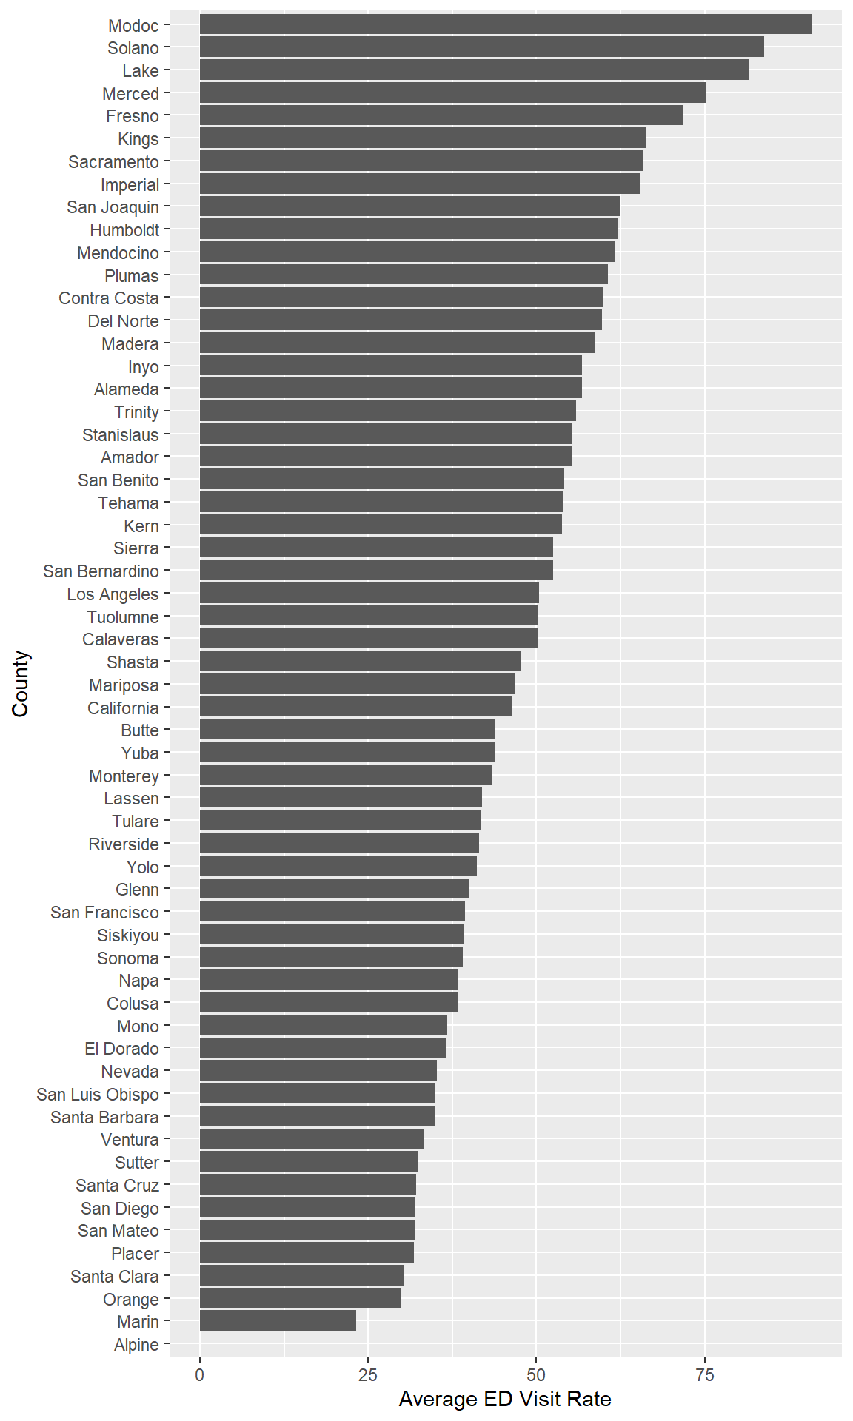

This shows the average population per county versus the Avg ED Visit Rate. Modoc county has a greater number of ED Visits.

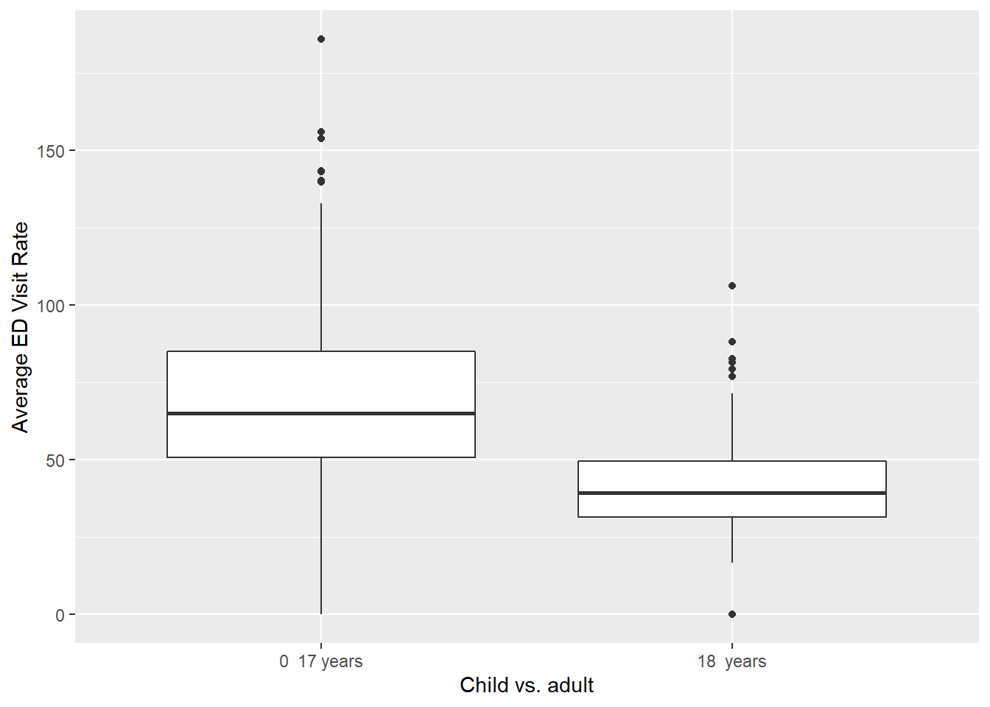

There are a greater number of cases in between 0 – 17 years Children than in Adult who are more than 18 years of age.

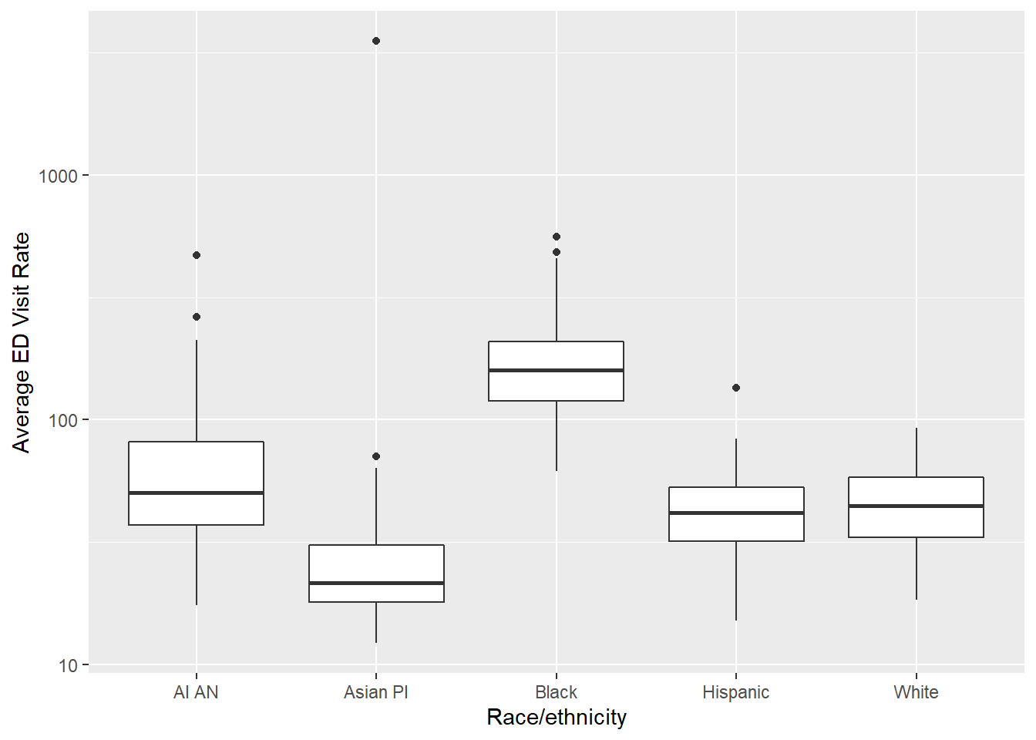

This shows a comparison between the Race/ Ethnicity and the Average ED Visit Rate.

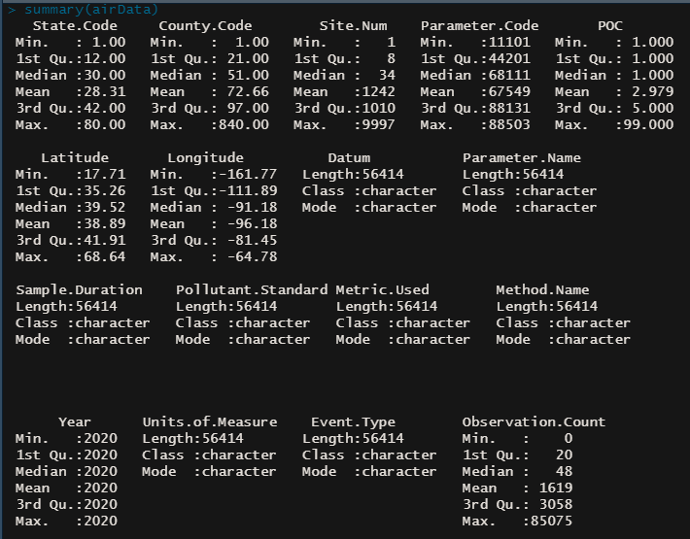

We did this by creating a few of layouts, that we presented to the stakeholders. During session, we discovered that certain diagram patterns encouraged greater interesting exchanges. Graphical analysis is a technique for intuitively analyzing trends - in other terms, employing visuals to understand the meanings.

**Conclusion:**

By reviewing the information, we produced a Dashboard from one of the applications and provided certain ways to develop Keva Health's technology. We developed detailed descriptions to allow relevant parties and statement comprehend how a data is indicating, how a modeling may effectively alleviate a problem, and also what impact the outcomes would have on the company. We'll conduct exploratory investigation in this manner. You can glimpse past the facts with knowledge discovery (EDA). When we delve deeper into the details, we gain extra understanding. For over 80% of our effort, we'll be using EDA to gather opinions and address numerous business difficulties. I'd like to employ machine learning algorithms to forecast the consequences of asthma symptoms.

I'll use the Graphics Monitor to examine and show the information in the future. Look for information on hospital admissions that are open to the general public and obtain the airnow dataset. Evaluate the effects of pollution levels on asthmatic patients by making analysis and creating a factual account. Suggestions for using this information to help respiratory sufferers.

**References:**

[1] Big Data Analytics: 6 Key Steps to Getting the Most out of your Big Data Project. *BI-Survey*. Retrieved from https://bi-survey.com/big-data-analytics-recommendations

[2] Alivia Smith. (July 4, 2019). 7 Fundamental Steps to Complete a Data Analytics Project. *Data Basics By Dataiku*. Retrieved from https://blog.dataiku.com/2019/07/04/fundamental-steps-data-project-success